**Lab Assignment 5**

An android application which has a Registration page and map api which helps to find the location of the captured image.

**Wire Frames:**

**Registration Page:**



**Output Map Page:**

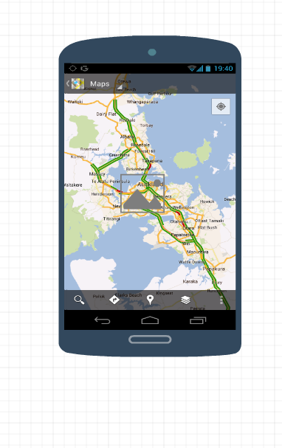

**Android Application Pages:**

**Registration Page:**

The Registration page contains First name, last name, Phone number and Address fields. Based on the location, the address get populated in the fields of the registration page when the screen loads. On Clicking on the camera button camera will be opened and we can capture the photo. After capturing the photo it will be displayed in the place of camera button. On clicking on the sign in button it will navigate to the Map page.

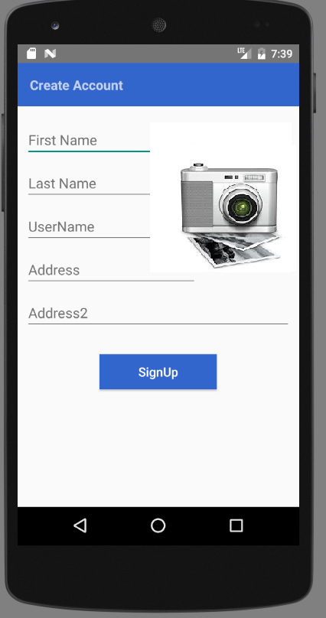

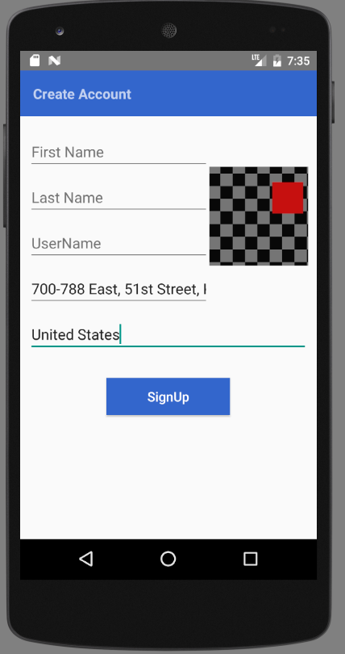

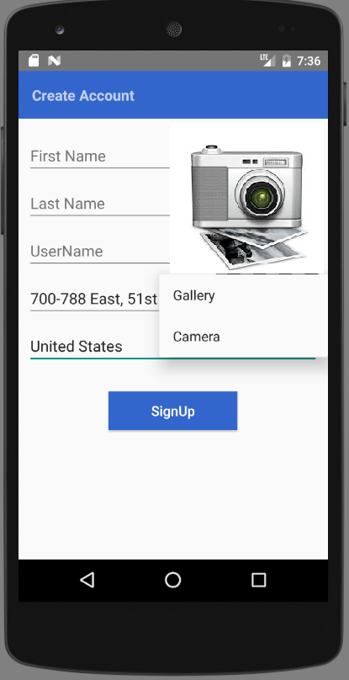



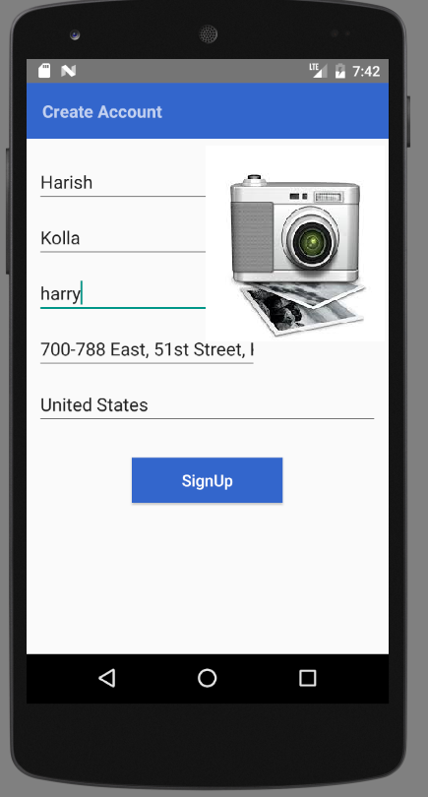

**Map Page:**

This page displays a map with the current location of the user and displays the image captured in the registration page in the current location.

